1. Launch one EC2 using Amazon Linux 2 image and add a script in user data to install Apache.

Step 1: Login to your AWS account as root user and select **EC2** 🡪 Launch instance and select the configurations to launch an instance.

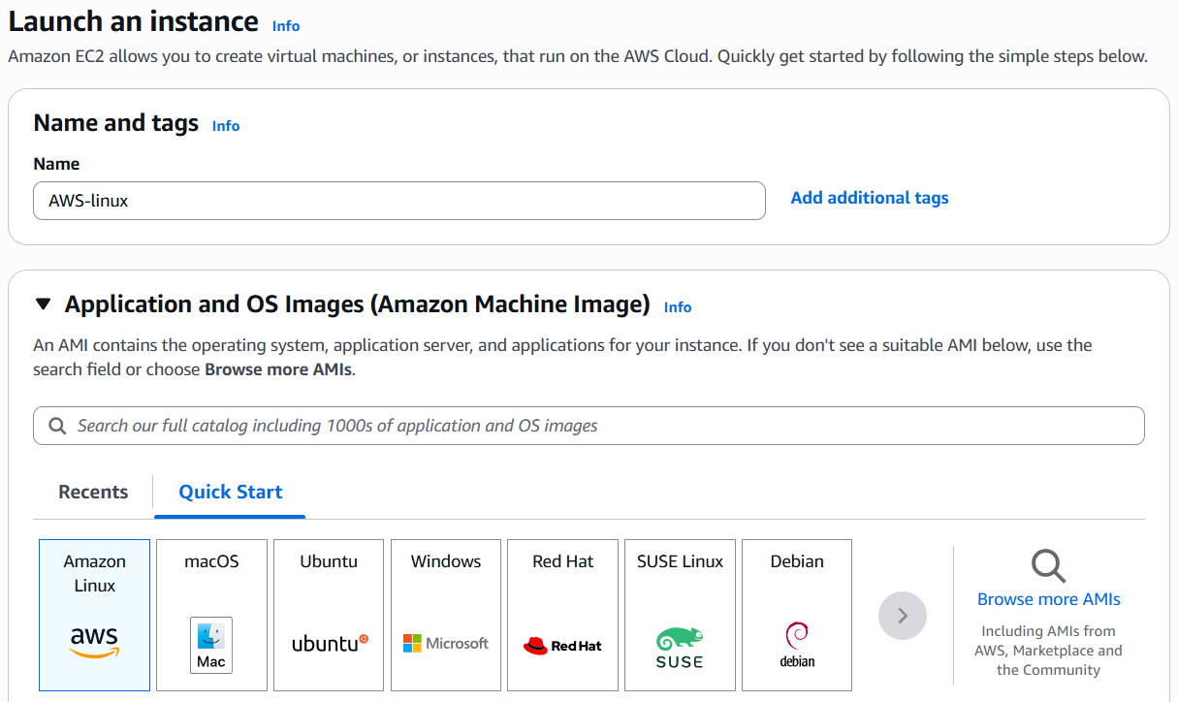

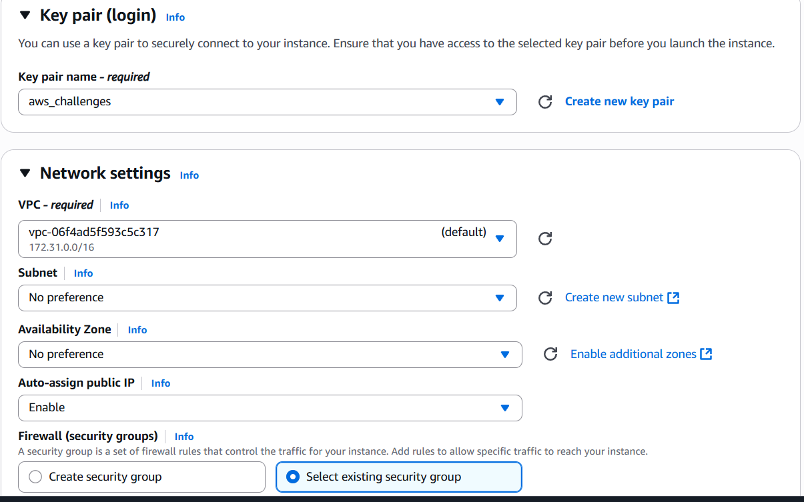

Step 2: Add the script in user data section to install apache and click launch instance.

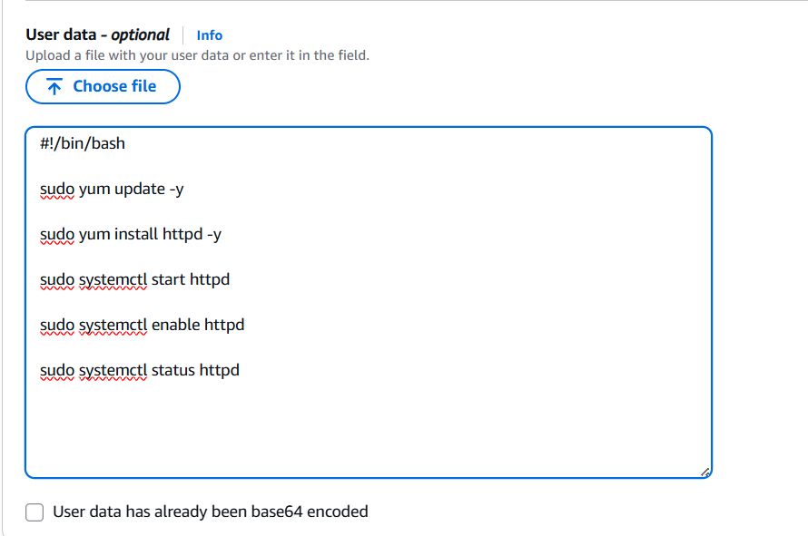

Step 3: Verify it by connecting to ec2 server.

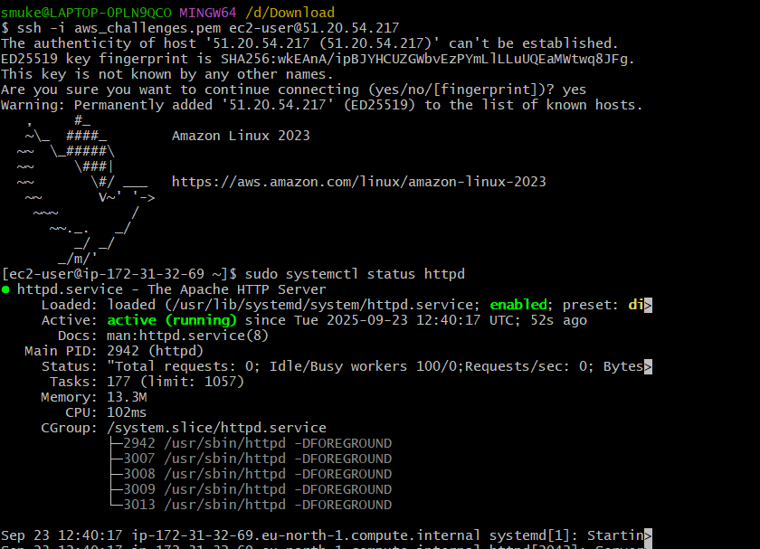

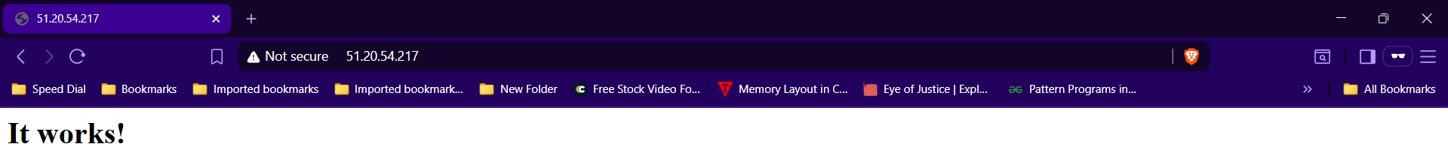

1. Launch one EC2 using Ubuntu image and add a script in user data to install Nginx.

Step 1: Login to your AWS account as root user and select **EC2** 🡪 Launch instance and select the configurations to launch an instance.

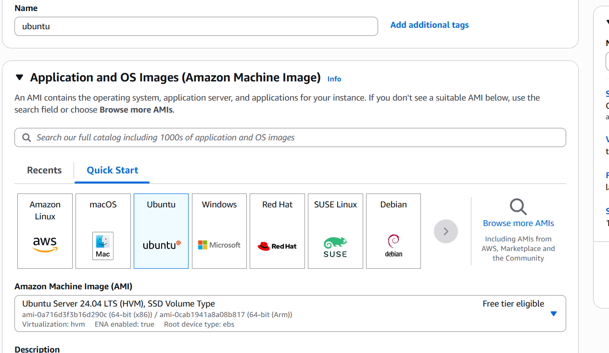

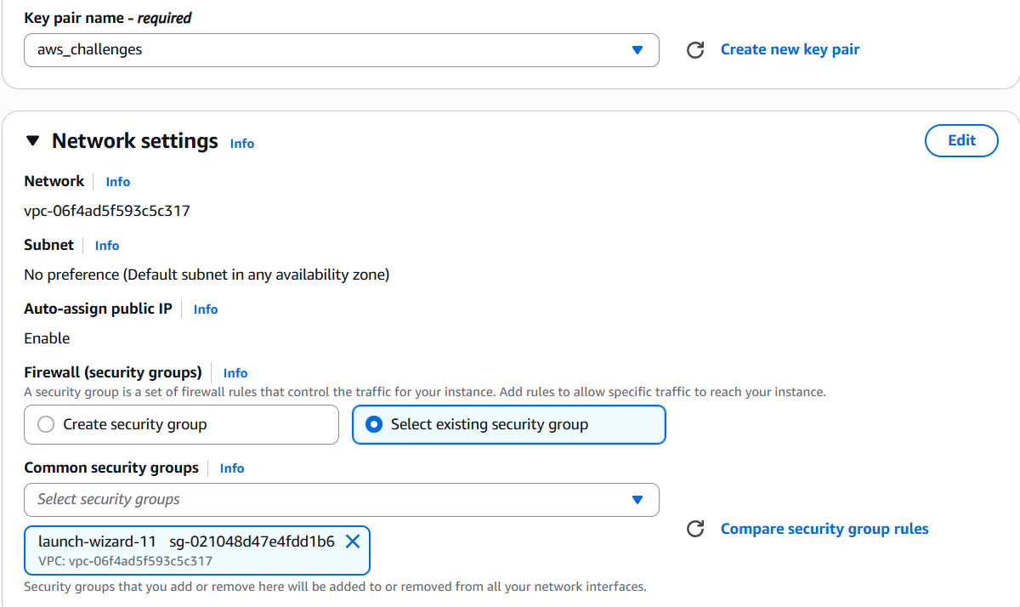

Step 2: Add the script in user data section to install nginx and click Launch instance.

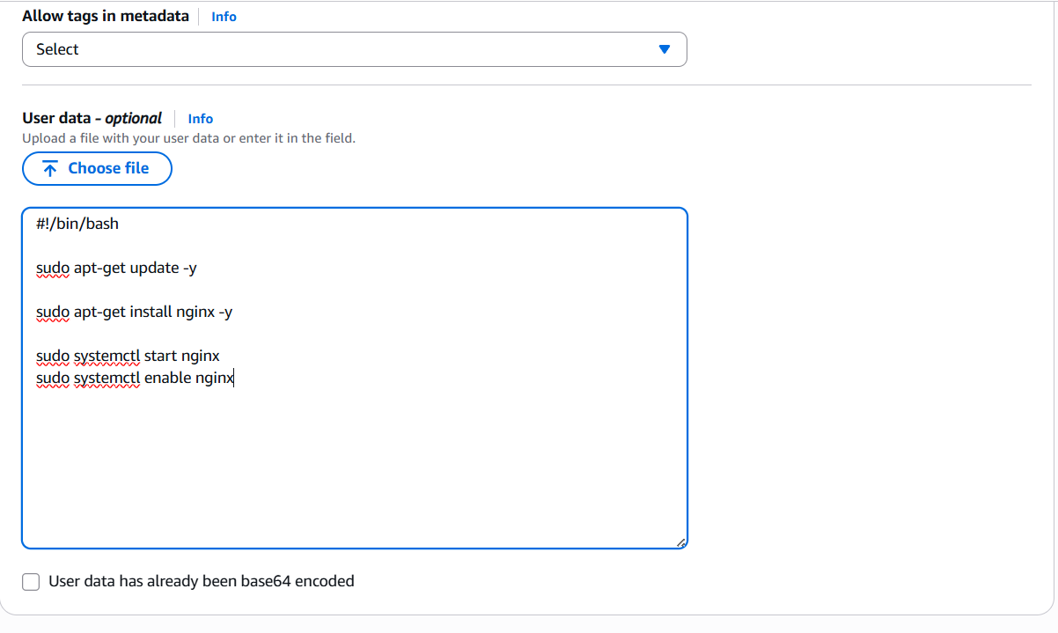

Step 3: Verify it by connecting to ec2 server.

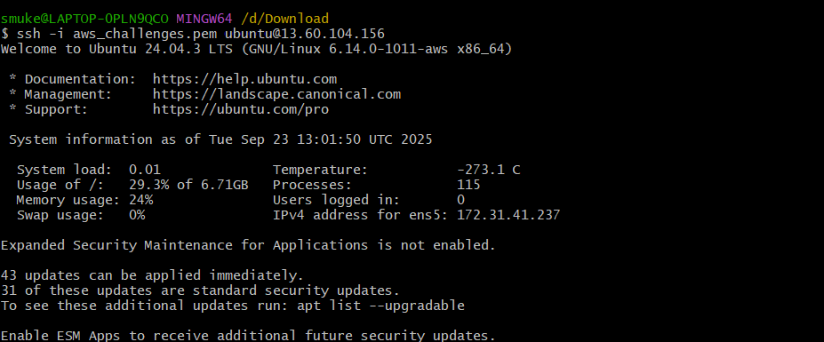

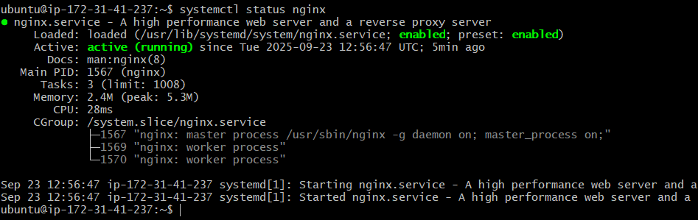

1. Launch one Windows server and install Tomcat on Windows.

Step 1: Login to your AWS account as root user and select **EC2** 🡪 Launch instance and select the configurations to launch an instance.

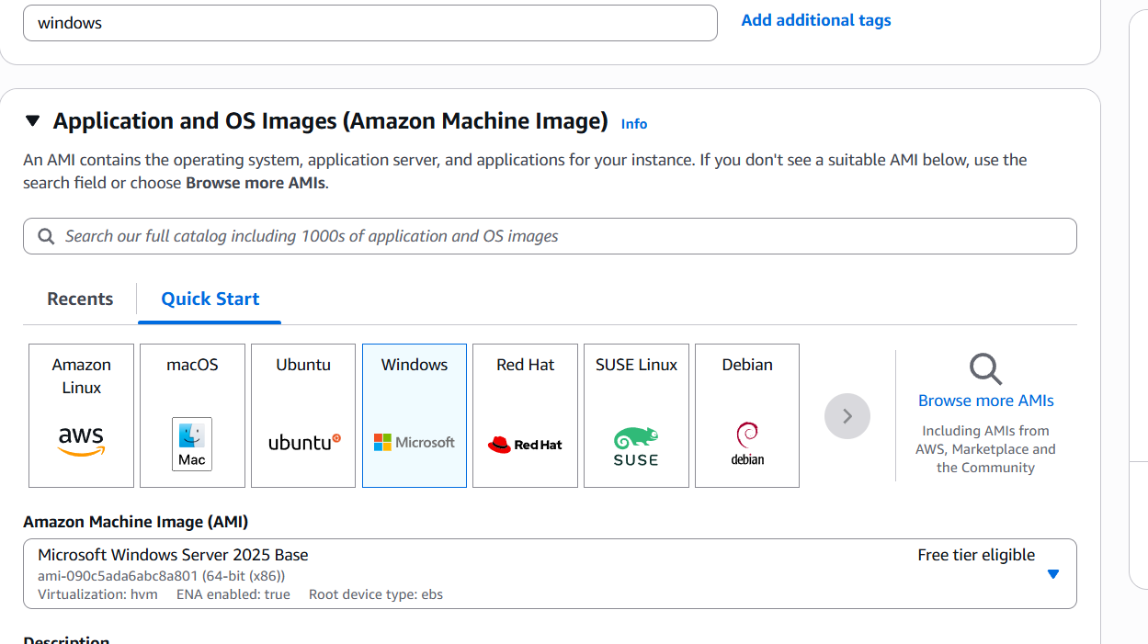

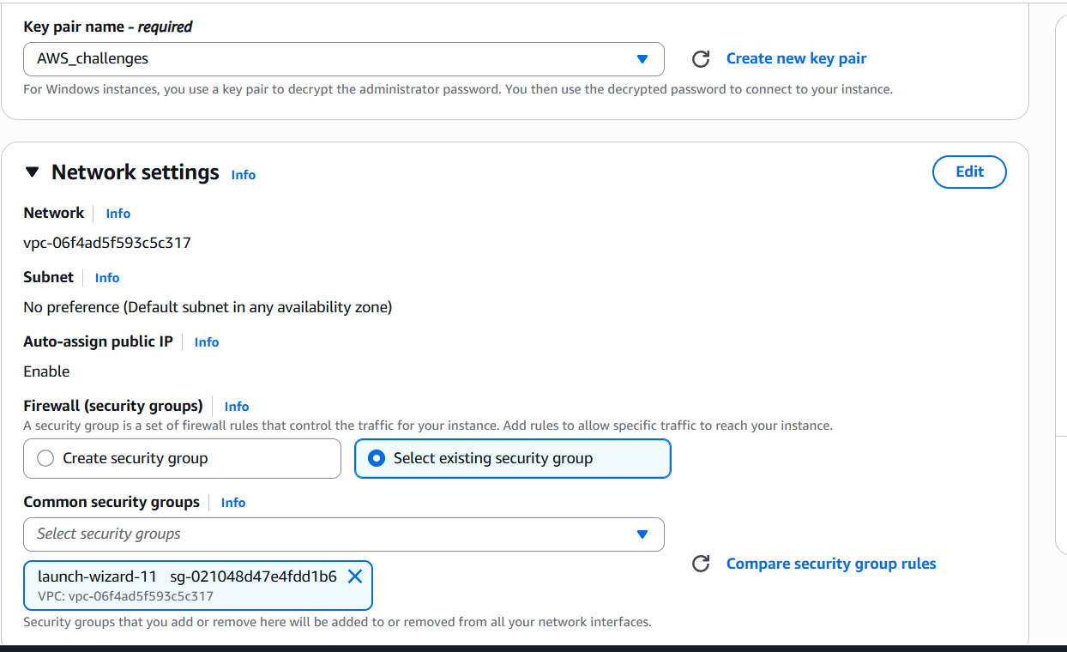

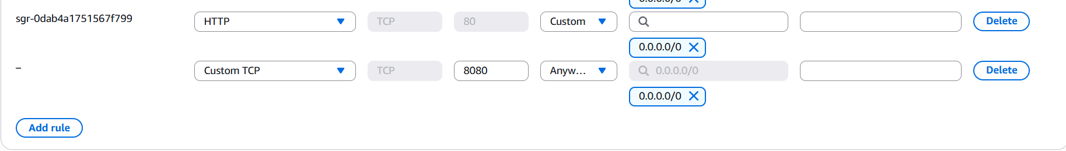

Step 2: Download and install Apache tomcat windows service installer and remote desktop.

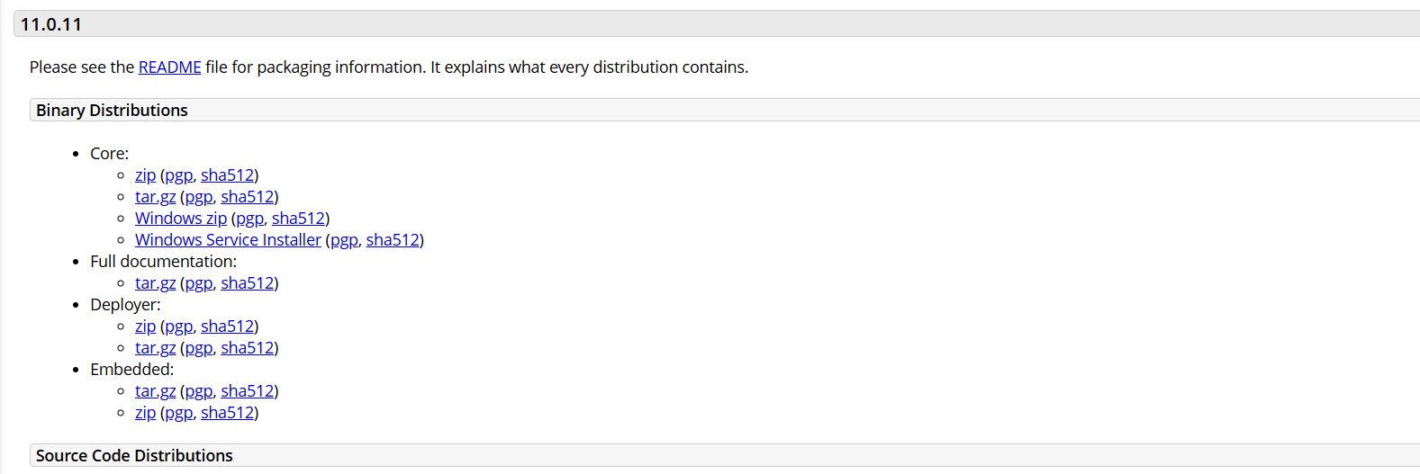

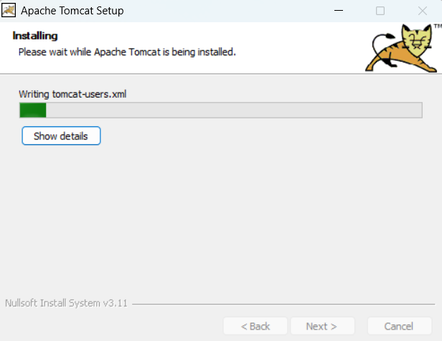

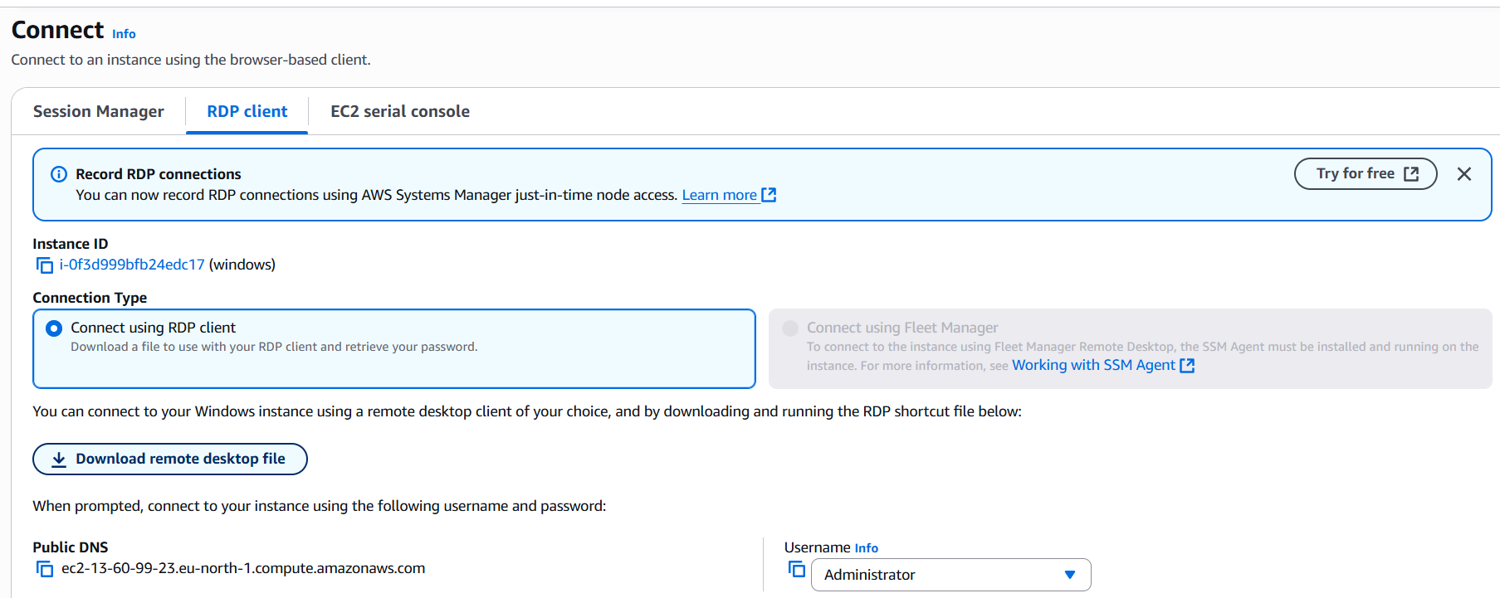

Step 3: Connect to the remote desktop and install java and apache tomcat.

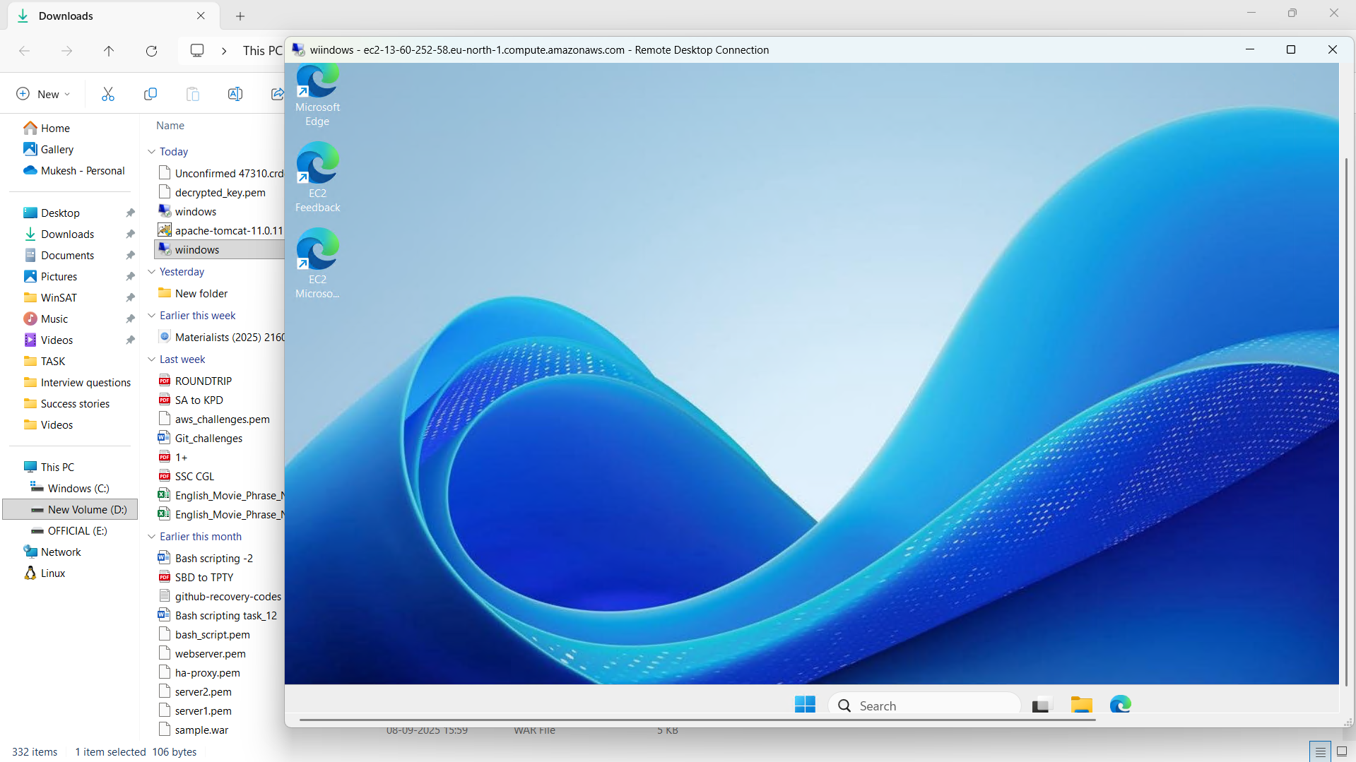





Step 4: Run **localhost:8080** in browser.

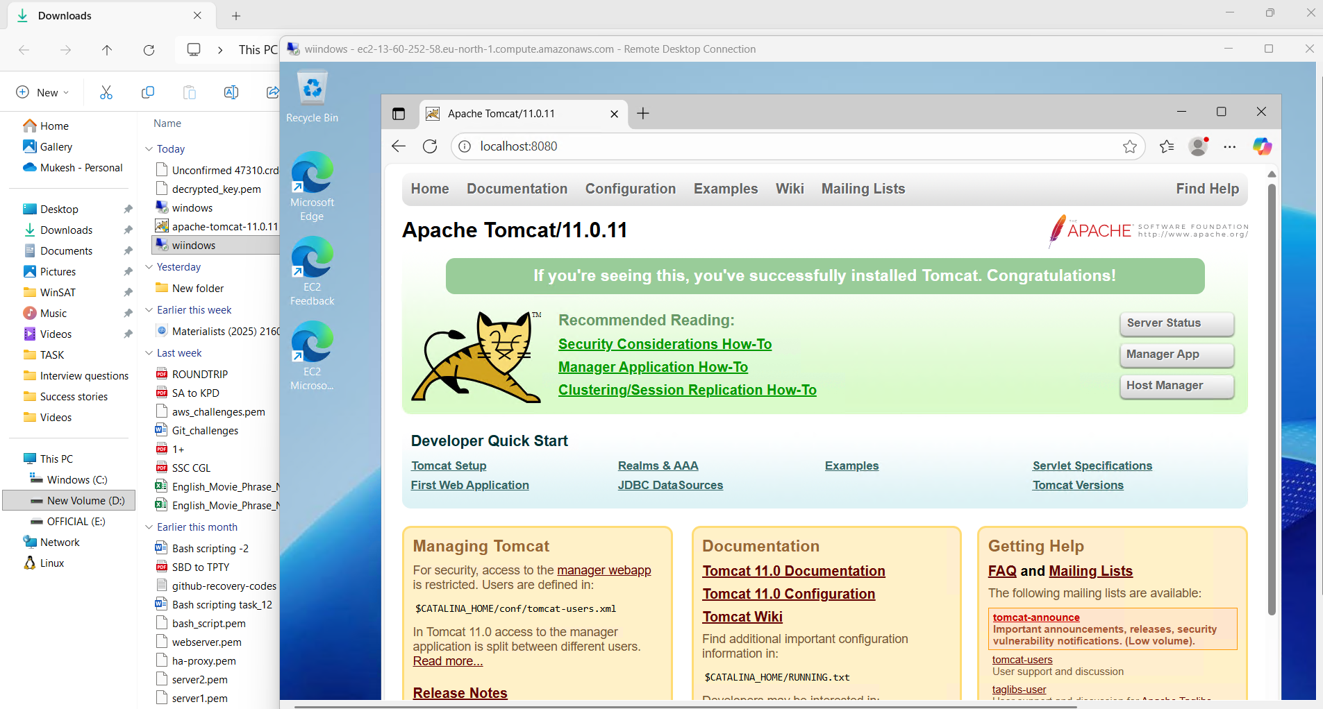

1. Take a snapshot of the instance created in Task 1.

Step 1: Select the instance to take snapshot and select volume in storage section.

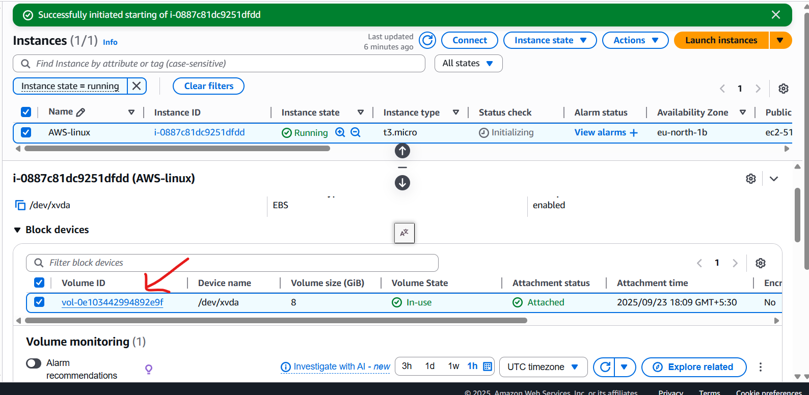

Step 2: Select the volume to take snapshot and click Action 🡪create snapshot.

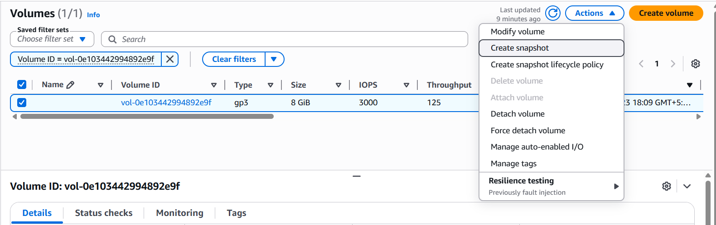

Step 3: Give snapshot description and select create snapshot.

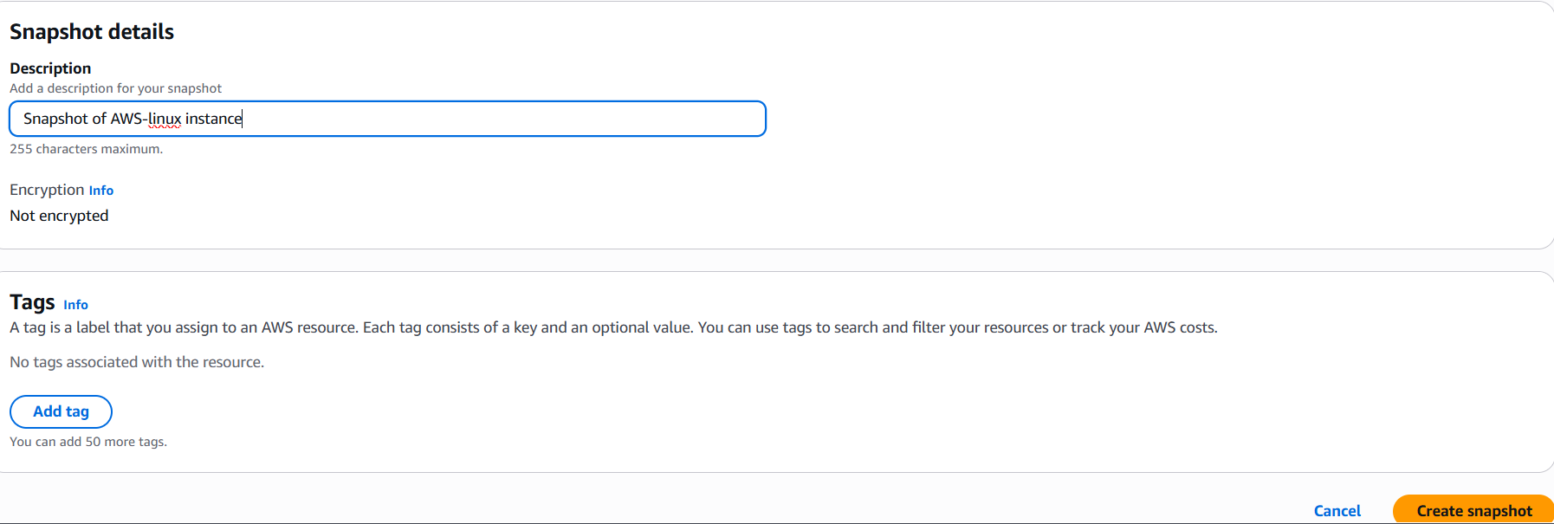



Step 4: Verify it in snapshot section under Elastic Block Store.

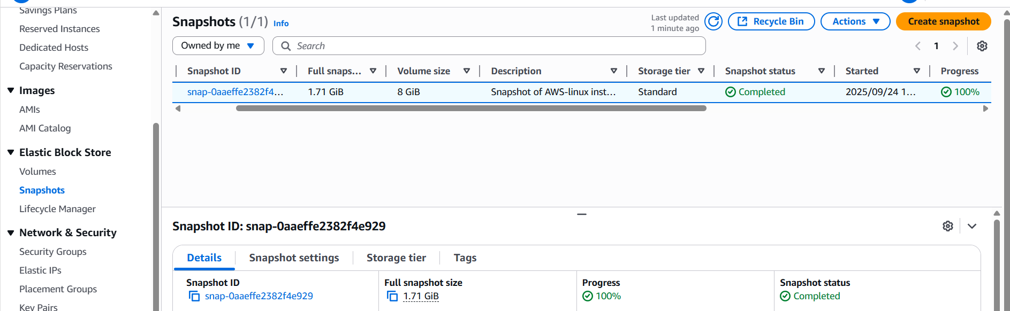

1. Assign passwordless authentication for the EC2 created in Task 2.

Step 1: Create a public key using **ssh-keygen** command and copy it.

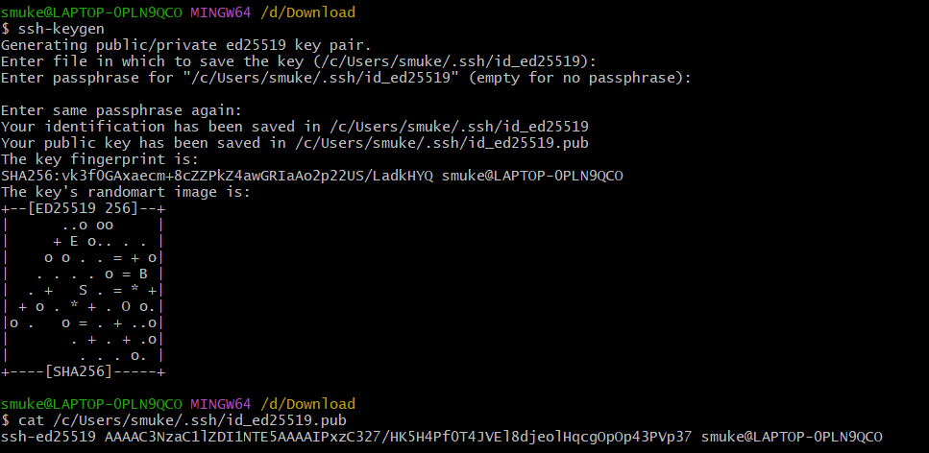

Step 2: Login to the instance and paste the public key in **authorized_keys** file and save it.

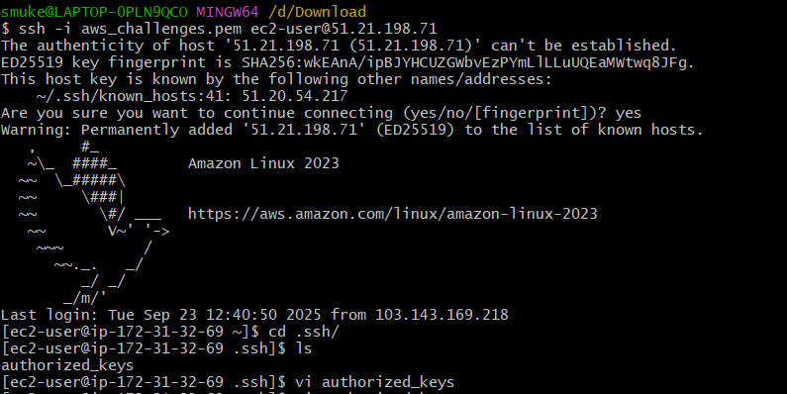

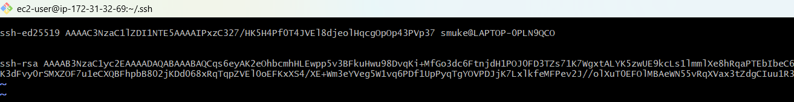

Step 3: Now login using **ssh user_name@public_ip.**

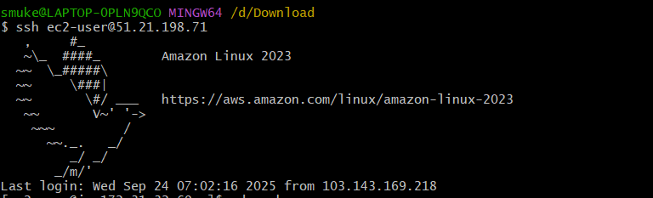

1. Launch any EC2 using the spot purchasing option.

Step 1: Select the required configurations and select spot instance 🡪 customise spot instance under purchasing option.

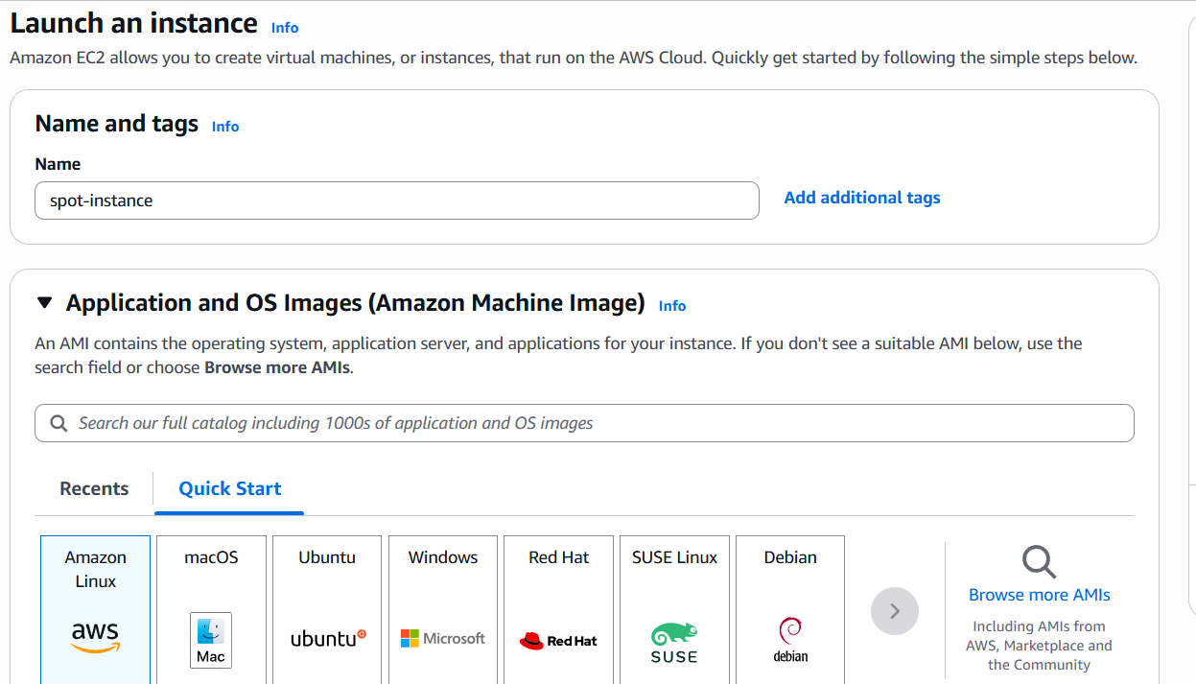

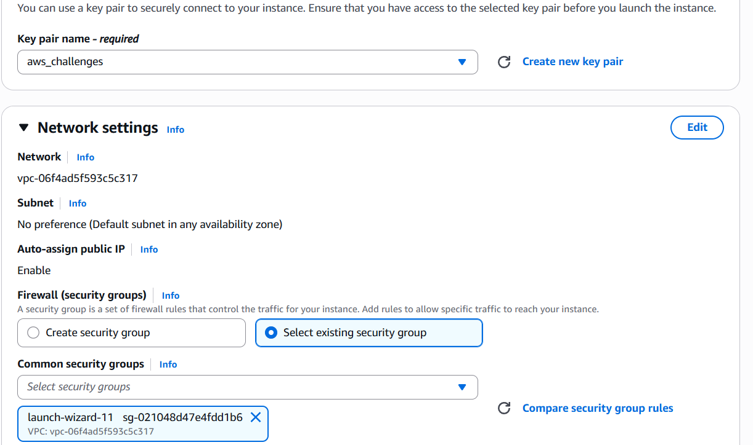

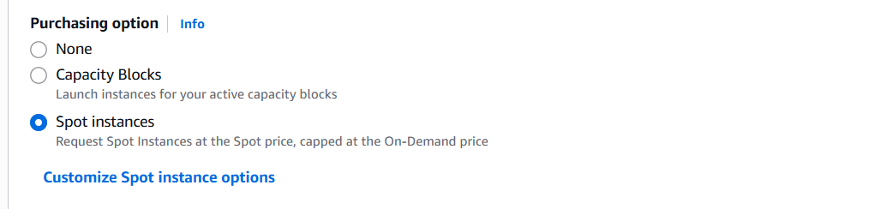

Step 2: Set maximum price and select Request type and Interruption behaviour and launch instance.

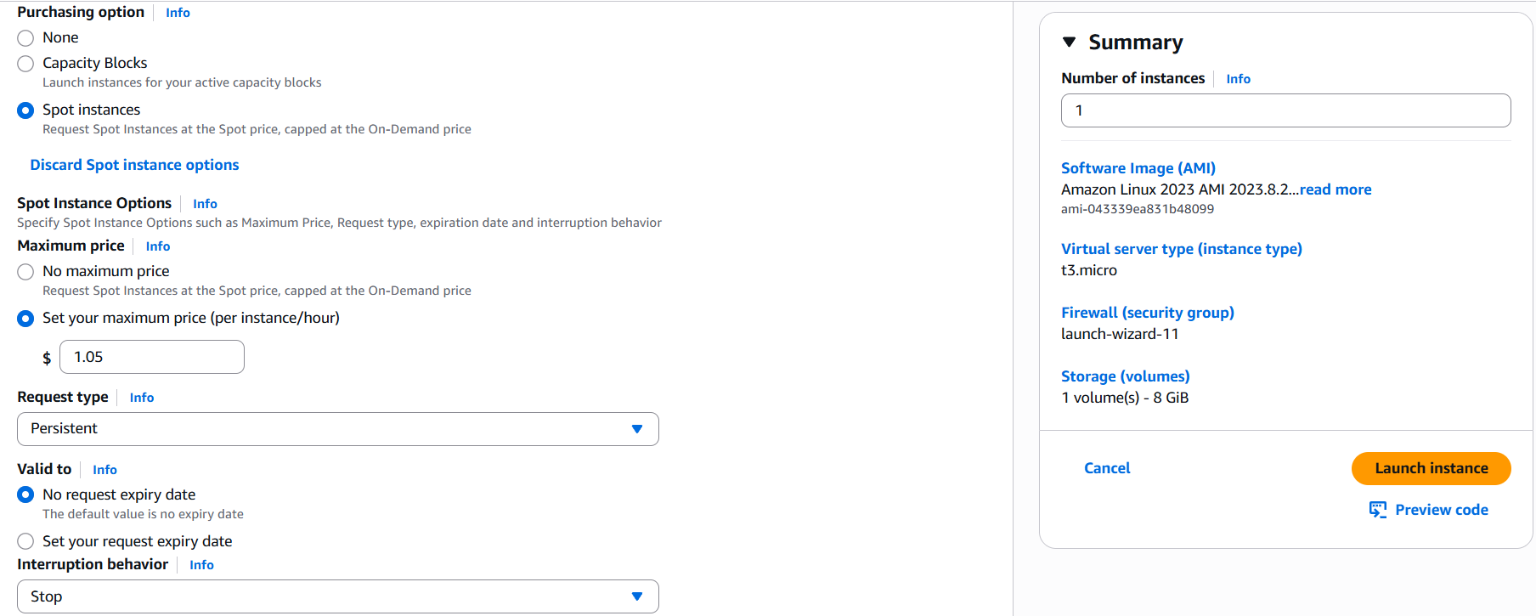



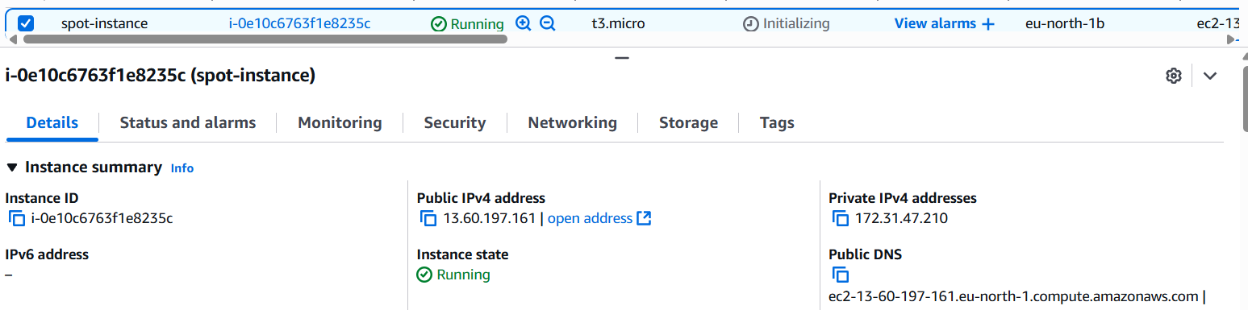

1. Enable termination policy on the EC2 created in Task 2.

Step 1:Select the instance and select instance settings 🡪 change termination protection under Actions menu.

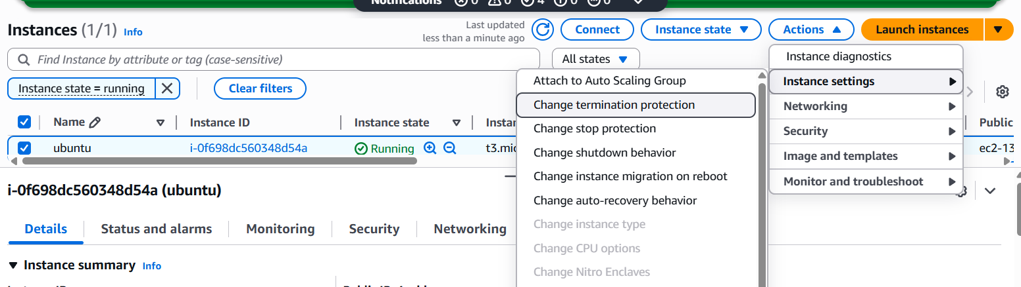

Step 2: Select Enable and save it.

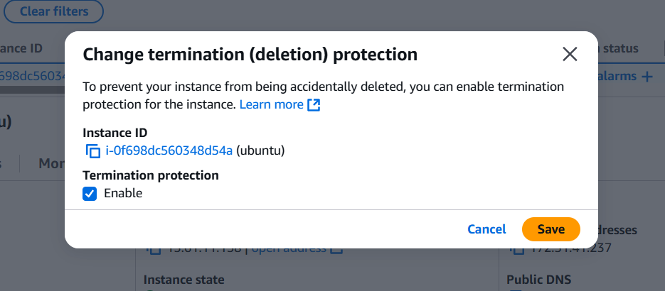

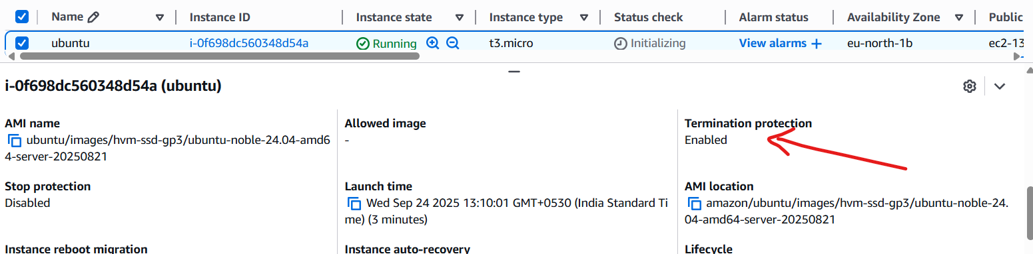

1. Launch one EC2 using AWS CLI.

Step 1: Download and install the aws cli.

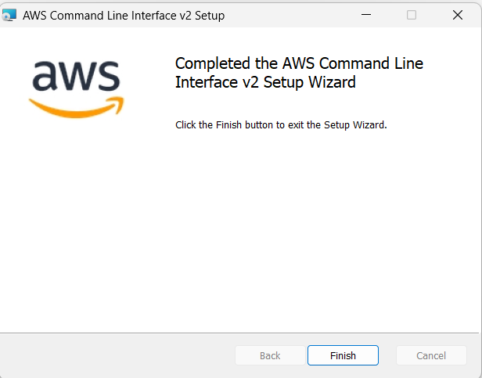

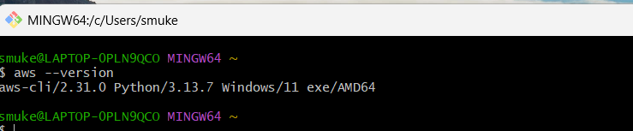

Step 2: Login to your aws console select **IAM 🡪 My security credentials 🡪 Create access key**

and copy access keys.

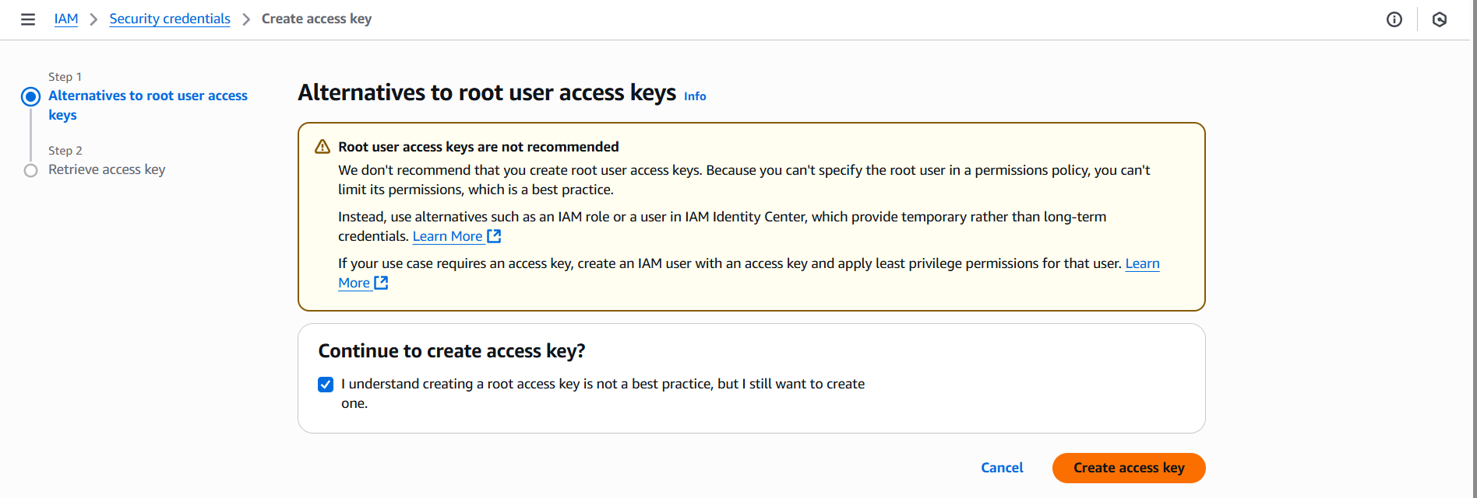

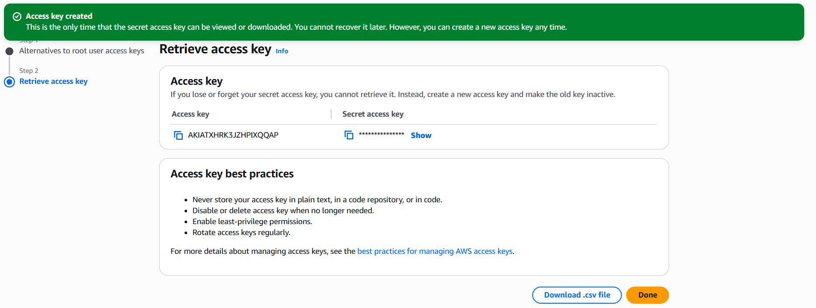

Step 3: Configure aws using **aws configure** command.

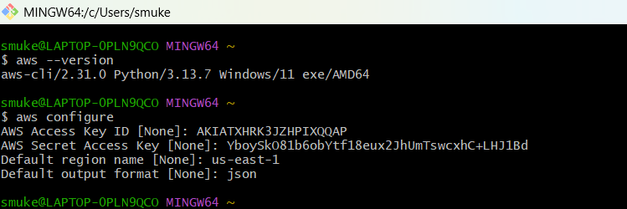

Step 4: Run **aws ec2 run-instances --image-id ami-03657b56516ab7912 --count 1 --instance-type t2.micro --key-name oct2020 --security-group-ids sg-0158ed0df68ca337c --subnet-id subnet-3edf3f55** to launch an instance.  
